Session vs. Cookies| Difference between Session and Cookies

The Session and cookies are used by different websites for storing user's data across different pages of the site. Both session and cookies are important as they keep track of the information provided by a visitor for different purposes. The main difference between both of them is that sessions are saved on the server-side, whereas cookies are saved on the user's browser or client-side. Apart from this, there are also various other differences between both. In this topic, we will understand the detailed description of sessions and cookies and how both are differentiated from each other.



What is a Session?

* **A session is used to temporarily store the information on the server to be used across multiple pages of the website**. It is the total time used for an activity. The user session starts when he logs-in to a particular network application and ends when the user logs out from the application or shutdowns the system.
* When we work on an application over the internet, the webserver doesn't know the user because the HTTP protocol does not maintain the state. The information provided by the user on one page of the application (Let's say Home) will not be transferred to another page. To remove this limitation, sessions are used. Session gets started whenever a visitor first enters a website.
* The user information is stored in session variables, and these variables can store any type of value or data type of an Object.
* Session values are much secured as these are stored in binary form or encrypted form and can only be decrypted at the server. The session values are automatically removed when the user shutdowns the system or logout from the application. To store the values permanently, we need to store them in the database.
* Each session is unique for each user, and any number of sessions can be used in an application; there is no limitation to it.
* The user is identified with the help of **sessionID**, which is a unique number saved inside the server. It is saved as a **cookie, form field, or URL.**

Working of Session

The working of a session can be understood with the help of the below diagram:

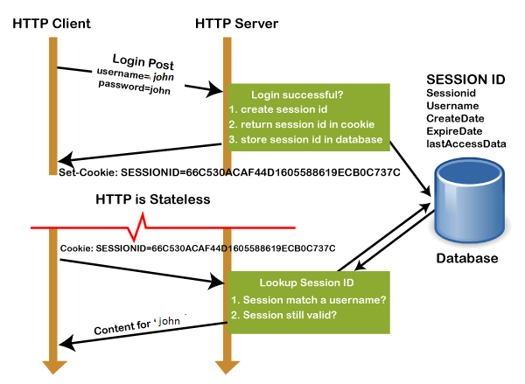

1. In the first step, the client request to the server via GET or POST method.
2. The **sessionID** is created on the server, and it saves the sessionID into the database. It returns the sessionId with a cookie as a response to the client.
3. Cookie with sessionID stored on the browser is sent back to the server. The server matches this id with the saved sessionID and sends a response **HTTP200**

Why Use Session?

* Sessions are used to store information such as UserID over the server more securely, where it cannot be tempered.
* It can also transfer the information in the form of value from one web page to another.
* It can be used as an alternative to cookies for browsers that don't support cookies to store variables in a more secure way.

What is Cookie?

* **A cookie is a small text file that is stored on the user's computer**. The maximum file size of a cookie is **4KB**. It is also known as an HTTP cookie, web cookie, or internet Cookie. Whenever a user visits a website for the first time, the site sends packets of data in the form of a cookie to the user's computer.
* The cookies help the websites to keep track of the user's browsing history or cart information when they visit their sites.
* It stores only the "String" data type.
* The information stored within cookies is not secure because this information is stored in text-format on the client-side, which can be read by anyone.
* We can enable or disable the cookies as per the requirement.
* The cookies generated by a user are only be shown to them, and no other user can see those cookies.
* Cookies are created and shared between the server and browser with the help of an HTTP header.
* The path where the cookies are saved is decided by the browser, as Internet explorer usually stored them in **Temporal Internet File Folder**.
* When we visit YouTube channel and search for some songs, next time whenever we visit YouTube, cookies read our browsing history and shows similar songs or last played songs.

# [Does a session variable stay in memory in php](https://stackoverflow.com/questions/32027037/does-a-session-variable-stay-in-memory-in-php)

No, sessions will be stored default in files (e.g. in /tmp).